Sean McLean
ALY 6980 Capstone
Professor Parker
Module 12
Individual Project Proposal

Problem Statement
The focus of the project proposal is to explore the role of digital tools in franchise growth strategies, focusing on how technology-driven franchise management influences operational success. Franchises today face a highly competitive market, shaped by data and modern technologies. To maintain relevance and drive growth, franchises must integrate these digital tools and leverage data-driven insights to enhance decision-making. However, challenges such as data security, compliance issues, and integration concerns often impede long-term growth and prosperity (Sabaran & Aziz, 2023). By incorporating customer relationship management (CRM) systems and data analytics tools into their strategic assessments, Big Sky Franchise Team can gain actionable insights to improve long-term business performance and streamlining of operations.
Business Purpose
The purpose strives to provide actionable recommendations using data-driven franchise management practices aimed at operational improvement and performance enhancement. The initial phase involves evaluating the impact of CRM, predictive analytics, and digital marketing tools on franchise performance metrics. The proposal will then identify the most ideal practices for data governance and decision-making to optimize franchise performance. The last step includes developing a strategy that will provide recommendations for Big Sky Franchise Team to enhance franchisee support, optimize performance, and capitalize on growth opportunities.
Literature Review
This proposal draws on industry articles, case studies, and scholarly research to underline the importance of integrating digital tools into franchise operations. Insights from the annotated bibliography highlight the essential role of CRM and analytics in franchise management. Studies on Flexible Working Practices (FWP) underscore both the benefits and challenges of digital transformation in workforce management, which is crucial for franchise performance. While technology can enhance operational flexibility, it can also lead to social isolation, increased stress, and blurred work-life boundaries. These findings emphasize the need for careful integration of digital tools in franchise management to ensure CRM systems and data analytics contribute to operational efficiency without negatively impacting employee engagement or franchisee relationships.
The research will also highlight the financial and technological challenges of FWPs such as job security concerns and performance monitoring difficulties which are relevant to the proposal’s focus on data governance and decision-making. Balancing technology adoption with sustainable practices is essential for maximizing long-term success. As franchises adopt digital tools to streamline operations and drive growth, they must address issues like data security, employee oversight, and ethical technology use (Soga, Laker, Bolade-Ogunfodun, Mariani & Nasr, 2022).
The Smart Dashboard System proposed for franchise organizations aligns well with the goals of this proposal. It demonstrates how digital tools can enhance franchise management and functional success. It allows franchisors to monitor franchisee performance, ensure compliance with company standards, and make data-driven decisions. It supports the proposal’s emphasis on integrating CRM and data analytics tools to improve franchise performance and growth opportunities. Research on dashboard systems also highlights the importance of design thinking in developing user-friendly and effective digital tools which can improve transparency and facilitate strategic decision-making (Nashrulloh, Seiawan, Satria & Supriatna, 2019).
The research into how Croatian franchisors utilize digital tools offers valuable insights by assessing their websites and communication channels. It highlights the role of digital presence in strengthening franchise networks, enhancing brand visibility, and contributing to business growth. A strong online presence can boost franchise recruitment, customer interaction, and sales conversions, particularly when combined with digital marketing strategies and e-commerce functionalities. This supports the proposal’s call for a comprehensive and well-executed online strategy to ensure competitiveness in the evolving market (Erceg, Kelic & Bilos, 2020).
Further studies indicate the use of digital platforms like FranchiseGlobal.com to enhance franchisor-franchisee relationships. These platforms provide a user-friendly interface that facilitates advertising, registration, and promotion, while also ensuring data security and compliance with industry standards. The ease of access to up-to-date, accurate data gives franchisors and franchisees a competitive edge, making it easier to identify new opportunities and mitigate risks associated with poor-quality data. These insights directly relate to the proposal’s goal of enhancing franchise growth through digital tools while also addressing the ethical and social responsibility challenges of platform use (Ningsih, Hamdi, Indradewa & Abadi, 2024).
A study examining the internationalization of hotel chains through franchising reveals the benefits of franchising as a non-equity expansion strategy. It demonstrates the importance of franchise experience, monitoring skills, and organizational size in successful international expansion. By integrating CRM and data analytics, Big Sky Franchise Team can optimize operations and support international expansion efforts, matching with the study’s findings that organizational factors and market conditions are key to international success. Digital tools can enhance monitoring, improve decision-making, and support long-term growth in the global market (Alon, Ni & Wang, 2011).
Approach
The proposed solution will be approached by incorporating multiple key business considerations:
- Business Leadership: The use of analytics in franchise management empowers leaders to make informed strategic decisions. Digital tools enhance customer engagement, implement new ways of operating and delivering services, and establish new revenue streams (Publicis Sapient, 2025).
- Data Governance: Proper data collection, storage, and security are crucial in managing franchise operations. This will ensure compliance with privacy regulations while maintaining accurate, dependable, and accessible data that is essential for making data-driven decisions. It also entails revisions to internal policies and procedures in IT functions that can impact the incorporation of data governance (MIS Quarterly Executive, 2017).
- Ethical and Social Responsibility Challenges: Digital tools in franchise management must be implemented responsibly to ensure fair business practices, protect customer and franchisee data, and prevent biases in decision-making processes.

Methodology
This study will feature franchisers, managers, and employees as experimental subjects to assess the impact of digital transformation on franchise operations. The participants in the study will complete surveys that allow for data-driven insights into the adoption challenges and how it can adjust to the digital transformation.
Based on the summary of Sabaran and Aziz (2023), an analysis can be proposed to evaluate the impact of mobile apps, data analytics platforms, and point-of-sale systems on customer experience and operational effectiveness. The analysis could involve a comparative study of performance metrics before and after adopting these technologies. It will also use correlation and regression analysis to explore the relationship between digital tools and key performance indicators and thematic analysis to identify recurring themes in qualitative data.
A cost-benefit analysis could also assess the financial impact and return on investment of integrating digital tools into franchise management. This comprehensive approach will validate the importance of technological advancements in enhancing business operations and promoting corporate growth. Some potential constraints to consider would be whether there is adequate funding, time, and personnel for analysis and research for the proposal.
Data Sources:
- Internal datasets provided by Big Sky Franchise Team.
- Publicly available franchise industry reports and benchmarks.
- Online databases from outside providers.
- Competitor analysis via financial reports and case studies.

Data Analysis Procedures
The collected data will be utilized in two primary ways:
- Predictive Modeling: Machine learning techniques, such as regression analysis and clustering, will be used to predict growth trends, optimize customer retention strategies, and identify business inefficiencies. A predictive analytics model can be applied to franchise sales data to identify which factors contribute most to successful locations. By analyzing historical sales trends and data, the model can recommend strategies for new franchise openings, targeted marketing, and cost reduction.
- A/B Testing and Recommendation Systems: Research will be compiled during a marketing study by dividing users into two groups and recording their responses to websites and campaigns. These user behaviors and preferences will be essential to creating new marketing strategies in the future. Through the usage of data from customer history, personalized marketing can also be developed for businesses. An example of this is streaming providers like Netflix or Spotify that build algorithms based on past user history that will recommend similar content for the customer (Barqar, 2024). The implementation of recommendation systems can also be beneficial in AI operations for franchisors and franchisees searching for information during the franchising process. It can be beneficial for businesses to try to improve their current model and improving processes while learning more about current customer habits and trends (Libava, 2023).
- Dashboarding: A business intelligence (BI) dashboard will be developed to visualize key performance indicators (KPIs), making it easier for franchise leadership to monitor trends and performance in real-time.

The dashboard prototype will be created to represent the data collection and analysis process, illustrating:
- Data sources
- Analytical tools used.
- Dashboarding and predictive modeling applications
- Decision-making framework based on insights.
- Implementation of benchmarking practices to see how other companies have successfully transitioned to digital platforms and methods and compare them to improve business models overall (McEuen, 2024).
- Visualizations to present that show analysis from Big Sky dataset where digital tools have been employed and where they can be most utilized in the future.
An example of this is studying what other countries like Honduras are doing to integrate digital technologies into companies last year (Kaggle, 2024). This can impact a franchise looking at past data to see how new technological trends can be a business asset. Through research and analysis, companies in different sectors can also incorporate new digital tools for future growth.
The dataset contains the website the company uses, whether it is publicly traded, the specific software the company uses, and when it began and last used the technology. It covers a three-month period from last year and the technology adoption over the range of time for each company and how they were adopted. There seems to be a sharp increase at the end of the time range where companies began using technologies after a lengthy period of stagnant behavior. Because a sharp increase begins right at the beginning of September, this could suggest some sort of launch that applied to many companies that were beginning to use certain technologies.
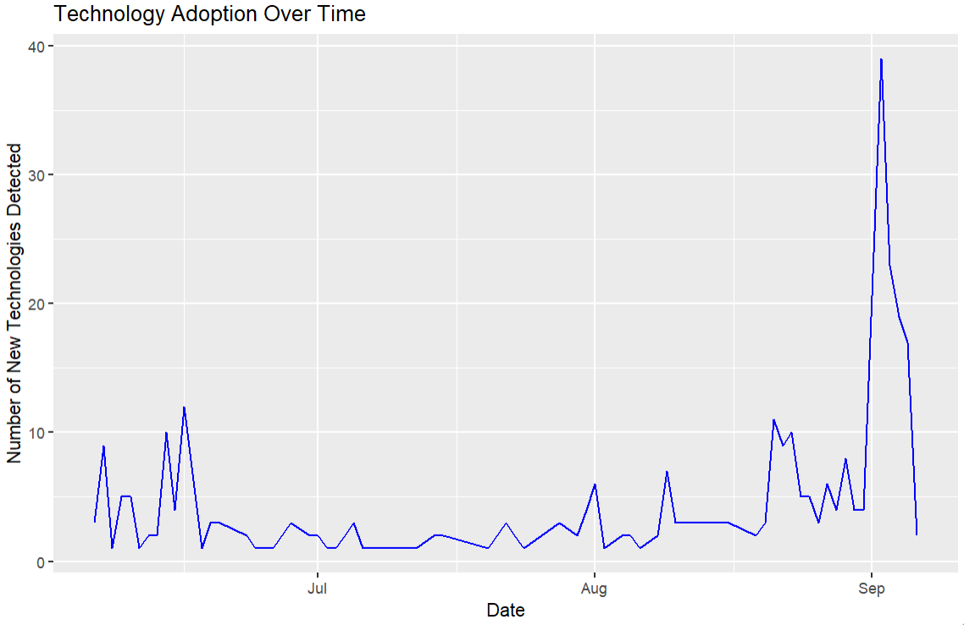
The other visualization built is a horizontal line chart that shows a count of the top 10 website domains from the data that companies are now using. The top two domains are Infosys and Wipro by a considerable margin over Samsung which may indicate that they are popular for the resources and services they offer with reasonable company rates.
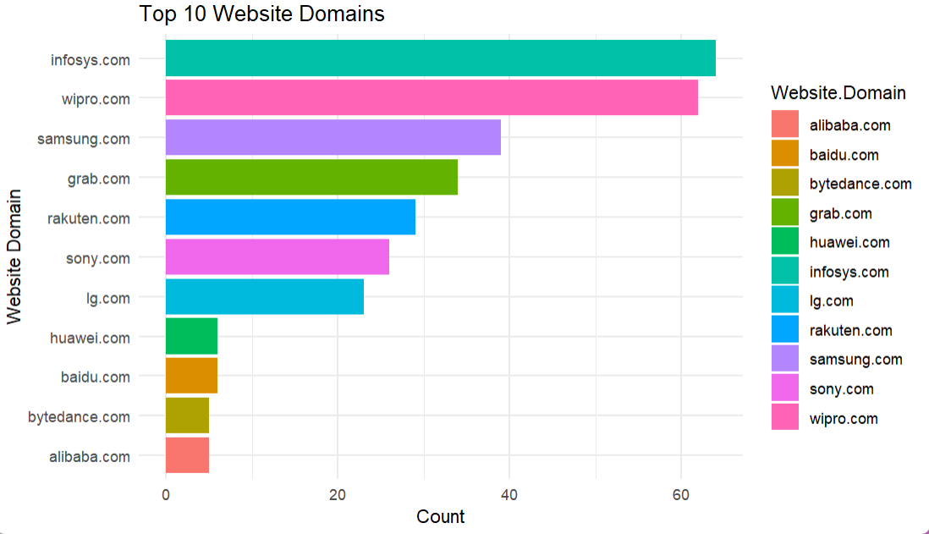

Survey Instrument: Defining the Survey Audience
The survey will focus on franchise owners, managers, and business executives within the Big Sky Franchise Team network. This group is pivotal as they actively use digital tools, oversee CRM systems, and make strategic decisions that influence franchise prosperity. Collecting and analyzing their feedback will help evaluate the effectiveness of current digital solutions and identify operational challenges.
Designing The Survey: The survey will feature a mix of structured and open-ended questions to collect both quantitative and qualitative insights.
- Quantitative Questions: These will measure key performance indicators, such as CRM tool effectiveness, the influence of data analytics on decision-making, and overall satisfaction with digital tools.
- Qualitative Questions: Open-ended responses will explore the challenges franchisees face with digital tools, suggestions for improvement, and perceptions of digital transformation in franchise management.
Sample Questions:
- On a scale of 1-5, how effective are CRM tools in managing customer interactions?
- What are the biggest challenges you experience when using digital analytics for franchise operations?
- What digital tools have been used in the past for franchise operations and which ones have been the most effective?
- How has digital tool integration influenced your ability to make data-driven decisions?
- How can the incorporation of digital tools strengthen relationships between the franchisor and franchisee?
Survey Deployment Plan
- Distribution: The survey will be conducted online and distributed through email and internal communication channels.
- Timeline: It will remain open for a month with a reminder sent at the end of the first week to encourage participation.
- Incentives: Participants may receive a summary of key insights to encourage engagement.
Data Governance Considerations
- Responses will be anonymous to ensure honest feedback, and participants will be informed about how their data will be used to enhance franchise operations.
- Ensure that all policies and procedures regarding data protection regulations are followed to avoid compliance concerns.
- Employees and customers must be informed on the collection and usage of data from how it will be used to ensure that the franchise is accountable and transparent.

Insights from this survey will help refine digital tool integration strategies, ensuring that CRM and analytics solutions match up with franchisee needs and drive company success (Sparkleminds, 2024).
Implementation Plan
- Phase 1: Data Collection & Analysis
  - Gather relevant data from company-provided datasets and external sources.
  - Perform comparative analysis with other franchising models.
- Phase 2: Small-Scale Pilot Testing
  - Conduct pilot test implementation in selected franchise locations.
  - Evaluate and measure the effect on customer retention and satisfaction and the efficiency of business policies and procedures.
- Phase 3: Full-Scale Implementation and Future Improvements
a. Incorporate digital tools into all franchise locations.
b. Collect continuous feedback for data-driven optimization.

Conclusions and Recommendations
This proposal presents an opportunity for Big Sky Franchise Team to integrate digital tools that will enhance decision-making and provide future guidance. By leveraging CRM and analytics, Big Sky Franchise Team will gain a competitive edge that will help enhance franchisee satisfaction, boost customer retention, and drive revenue growth. This will also result in improved digital business leadership practices that will feature digital inclusion, transform business operations, and increase the responsibilities that protect the planet (Claremont Lincoln University, 2025).
Recommendations for the proposal from this point forward include the presentation of findings with both short-term and long-term implementation strategies. Then assess potential challenges and propose mitigation strategies before providing a roadmap with realistic timelines for adopting proposed changes. Overall, the proposal will effectively complement the group project that seeks to improve future outcomes for Big Sky Franchising Team.
References
Publicis Sapient. (2025). Digital Business Transformation: The Guide to Future-Proofing Your Business. Publicis Sapient. https://www.publicissapient.com/digital-business-transformation?utm_source=google&utm_medium=paid-search&utm_campaign=BRAND_ALW_DBT_07.2024_Paid.Search_Google_Text_US_GEN_OF.NO&utm_content=BRAND_ALW_DBT_Digital.Transformation_2&utm_category=Brand&OfferingFamily=OF.NO&utm_term=digital%20transformation&gad_source=1&gclid=CjwKCAiA74G9BhAEEiwA8kNfpfKGUk2sCz8k2lyg4LKVUn05WAoyvhgPVAOX3zJNzYOSpsPQD3sgkRoCM18QAvD_BwE
Claremont Lincoln University. (2025). Digitial Leadership: Benefits And Strategies For Organizational Leaders. Claremont Lincoln University. https://www.claremontlincoln.edu/news-blog/digital-leadership-strategies/
Sparkleminds. (2024, May 9th). Steps To Create the Perfect Franchise Questionnaire before appointing a franchisee in India. Sparkleminds. https://www.sparkleminds.com/2024/05/09/steps-to-create-an-effective-franchise-questionnaire/
Sabaran, N. N. H., & Abd Aziz, N. A (2023, Dec. 11th). Technology Adoption In Franchising Business: Understanding Factors And Challenges. Journal of Technology and Operations Management, 18(2), 49-59. https://doi.org/10.32890/jtom2023.18.2.4
Ningsih, S., Hamdi, E., Indradewa, R., & Abadi, F. (2024, Oct. 25th). FranchiseGlobal.com: Digital Media Strategy in the Development of Franchise Industry and Business Opportunities in Indonesia. Journal La Bisecoman Vol. 05, Issue 05 (814-831), 2024. https://newinera.com/index.php/JournalLaBisecoman/article/view/1682
Alon, I., Ni, L., & Wang, Y. (2011, Jan.). Examining the determinants of hotel chain expansion through international franchising. International Journal of Hospitality Management. (PDF) Examining the determinants of hotel chain expansion through international franchising
Soga, L., Laker, B., Bolade-Ogunfodun, Y., Mariani, M. & Nasr, R. (2022). Unmasking the other face of flexible working practices: A systematic literature review. Journal of Business Research 142 (2022) 648-662. https://www.sciencedirect.com/science/article/pii/S0148296322000364?via%3Dihub
Nashrulloh, M., Setiawan, R., Satria, E & Supriatna, A. (2019). Designing smart dashboard system towards digital leadership in franchise organizations. Journal of Physics Conference Series. https://iopscience.iop.org/article/10.1088/1742-6596/1402/2/022085/pdf
Erceg, A., Kelic, I. & Bilos, A. (2020, Dec. 30th). Evaluation of franchise system websites: the evidence from Croatia. Engineering Management in Production and Services, 13(1), 27-40. https://intapi.sciendo.com/pdf/10.2478/emj-2021-0002
Techsalerator. (2024). B2B Technographic Data in Honduras. Kaggle. https://www.kaggle.com/datasets/techsalerator/b2b-technographic-data-in-honduras/data
Barqar. (2024, Jan. 2nd). Top Strategies for Data-Driven Decision Making in Digital Marketing. Barqar. https://www.barqar.com/2024/01/02/data-driven-decision-making-digital-marketing/
McEuen, K. (2024, Feb. 27th). How Do I Use Franchise Analytics for Business Growth? Profit Keeper. https://www.profitkeeper.com/blog/how-do-i-use-franchise-analytics-for-business-growth/
Libava, J. (2023, Feb. 28th). Franchising And AI: Is Your Franchise Information Coming From A Human? The Franchise King. https://www.thefranchiseking.com/franchising-ai
Urbach, N., Drews, P., & Ross, J. (2017, Jun.). Digital Business Transformation and the Changing Role of the IT Function. MIS Quarterly Executive, 16, 2, 2017, p. 2- 4. (PDF) Digital Business Transformation and the Changing Role of the IT Function

